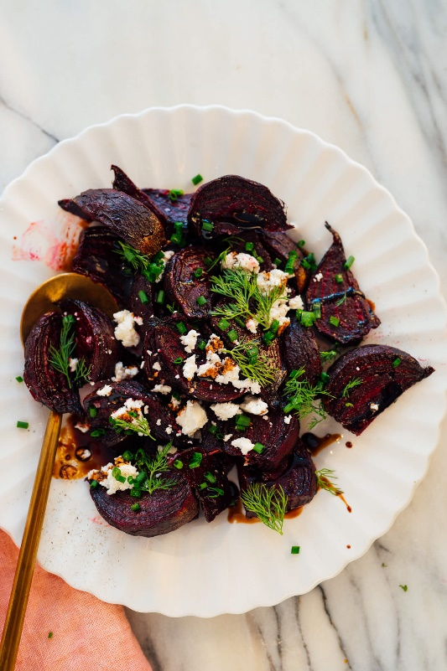
These roasted beets are for everyone! If you already love beetroots, I think you’ll be a big fan of this foil-free, no-peeling-required roasted beet recipe. If you don’t enjoy beets (yet), this roasting method just might change your mind.
These roasted beets feature lightly caramelized, tender-but-not-quite-crisp exteriors and deep, condensed flavor. I don’t love beets in all applications, but these? I have to stop myself from devouring the whole pan before dinner.
With this method, simply scrub the beets well before baking. No need to peel before or after baking. The skin, which is perfectly edible, just seems to disappear during the baking process.
The trick to pan-roasted beets is to drop the temperature a bit. I always roast potatoes, Brussels sprouts, carrots, and pretty much all the other veggies at 425 degrees Fahrenheit.
For beets, since we don’t want crispy outsides (tender is nicer), we’ll roast at 375 degrees. Easy!

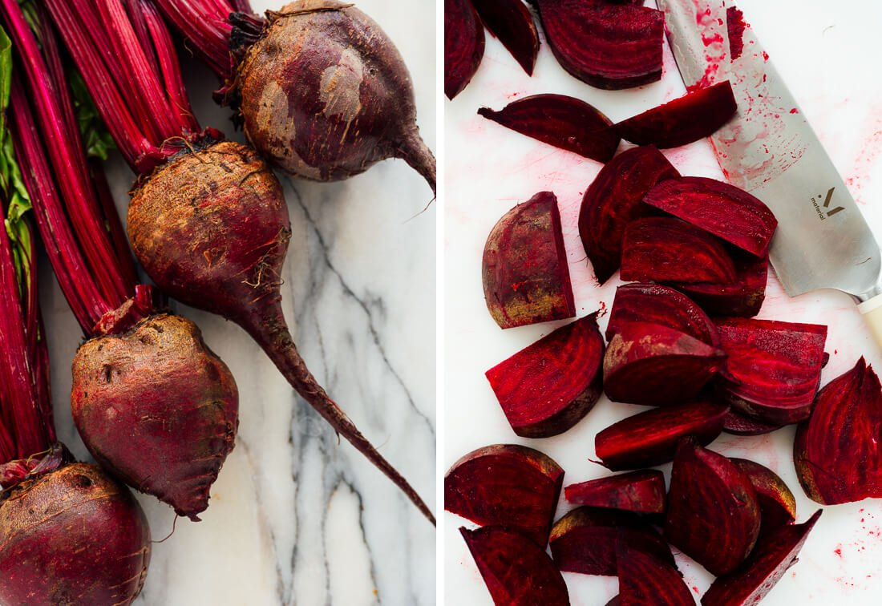

How to Serve Roasted Beets
Enjoy these roasted beets as a simple side dish, or gussy them up as I did in the first photo (I used fresh dill, chives, goat cheese and a thick balsamic vinegar).
You can also serve them as a component within your meal, or on top of a hearty salad. You’ll find some suggestions below to help you improvise.

Flavors that pair well with roasted beets:
- Arugula and other bold greens, including collard greens
- Avocado
- Balsamic vinegar, as well as red wine vinegar and apple cider vinegar
- Black pepper
- Carrots
- Creamy cheese and dairy, including feta, goat cheese, blue cheese, ricotta, crème fraîche, sour cream and plain yogurt
- Fennel
- Fresh herbs, including dill, basil, chives, mint, parsley, cilantro, tarragon and thyme
- Honey and maple syrup
- Lemon and orange
- Lentils (here’s how to cook them)
- Nuts and seeds, including pistachios, hazelnuts, walnuts, pecans, pine nuts, pepitas and sunflower seeds
- Onions, especially green, red and shallots

